

Name: S DIVYASREE A/P U SAKATHAVEN

Login ID : [divyasree@oasis-portal.com](mailto:divyasree@oasis-portal.com)

Course Title:Essentials of marketing and customer relationship

Subject code: BHM01

Submitted Date:17july2017

**Table of Contents**

|  |  |  |
| --- | --- | --- |
| **No** | **Details** | **Page** |
| 1 | Executive Summary | 1 |
| 2 | Introduction | 2,3 |
| 3 | Assignment Question |  |
|  | Part 1 | 45 |
|  | Part 2 | 7,6,8 |
|  | Part 3 | 9,10 |
|  |  |  |
| 4 | Conclusion | 11,13 |
| 5 | References | xxx |
|  | Appendix |  |

**Executive Summary**

In this task, the first thing that I understand is the definition of the marketing and the customer service relationship. After understanding their aspect I will able to characterize about the marketing in hospitality and the importance of hospitality marketing in the first part. Furthermore the I will be defining the difference between marketing and customer service, along with that I am also going to brief the ethics of marketing and customer service. In third part I capable to explain about marketing strategies and how I can apply the studies in hospitality organization. Finally, I am competent to describe in the detail on customer service skills and typical features, in addition I am also explaining the importance of hospitality of customer service.

**Introduction**

Do you know what is the definition of the marketing and customer relationship? First of all I am going to define the definition of the marketing. Marketing is when a company determine the needs of the customer and make conclusion to satisfy their demands. Marketing also essential can brief as the process of advertising and trending the products along with the analysis of the marketing.Marketing is mainly focus on the product and services, promotion, information and pricing. This marketing is to study the needs of the different customer from their prospect what they need. Secondly I am competent to brief the definition of the customer relation. Customer relation is a system that a firm to be establish and manage the connection with the customer. Furthermore, customer relation is communicating with the customer about the services, the way to improve the productivity and the complaints toward customer view.In other words it can be define as listen to customer. It gives the important role to the customer to product design, quality and pricing because we need to see the eyes of the customer as satisfying the needs of the customer.

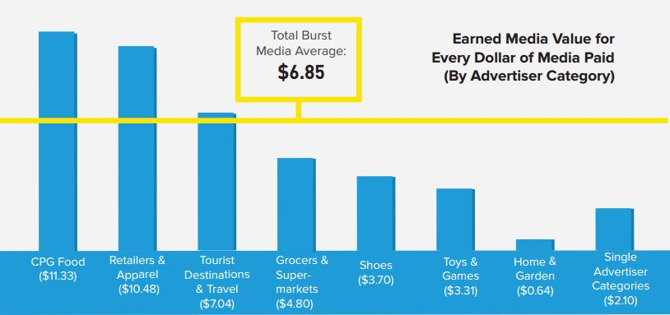

Statics 1.1 advertising category cost of marketing

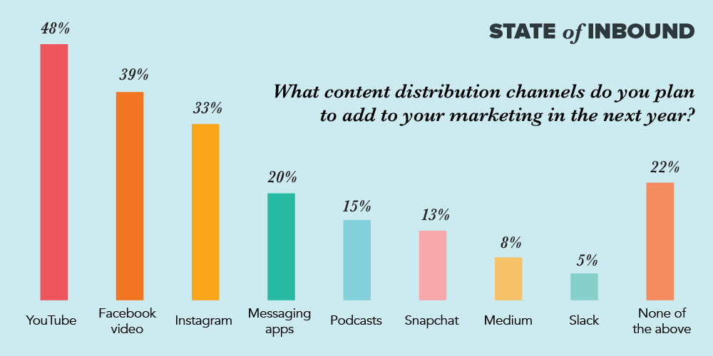Statistic 1.2 most popular social media towards customer.

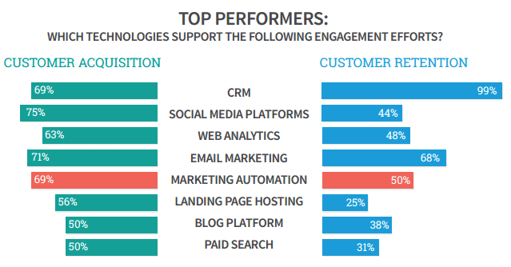

Statics 1.3 engagement efforts of customer acquisition and retention.

Question 1

1. Briefly explain about Marketing in hospitality and the important of hospitality marketing.(20 Marks)

* Marketing in hospitality.

Marketing in hospitality is apply to increase the profit target of the marketing towards the hotel industry. Furthermore, marketing is method to achieve a product and services to the customer. Hospitality in marketing is taking a important role to identify the marketing process,to see how there promote their products an services towards the hospitality industry such is hotel, motel, resort, outlet, restaurant and others. This help them to classify things easily and to make decision in the marketing in hospitality. Marketing is not only sales. Marketing in hospitality is also known as the process of the identifying, classifying, predicting and satisfying the consumer requirements. Marketing in hospitality is includes with the sales promotion, advertising, pricing, social media,customer relation and distributing. Moreover, the hospitality marketing function is to communicate and give the best value to the consumer. In hospitality marketing the organization of the company must circumspect the shareholder, employees, and the out world society. Other than that, there also must consider the 4 elements the marketing in the hospitality to look for the best profit. The 4 elements are place, pricing, promotion and product. The knowledge of the marketing is mainly target to provide the consumer satisfaction.

* The importance of Hospitality Marketing.

Customer satisfaction

Customer satisfaction is the result of the equivalence interpolated by product function and customer expectation in hospitality marketing.When product function is equivalent to customer expectation, the customer will be satisfied. When the product function is lower expectation from the customer expectation the product will be unsatisfied.

Corporate image

The one of another importance of the hospitality marketing is corporate image. Marketing support a business to be upgrade the corporate image and develop it by step by step in hospitality. Because of the help of the marketing a business can achieve their goal. Example as, increase the profit, market shares and sales. With this it help in mind of the consumer, employees, shareholder and other who involve in the firm.

Competitive Advantage

The next importance in hospitality marketing is competitive advantage.Hospitality marketing support to face competition in the market. Making a good decision is always taken by a experienced marketers. Because they will come up with promotion schemes, different and creative designs and models, and know of the effective customer method.

Expansion of firm

Hospitality marketing will develop the accomplishment of the business, which facilitates the expansion of the business. With this it can help the business to grow or expand from local to national, national to international market. To expand the firm, the business will undergo with the process example as market penetration, market development and product development.

Brand Loyalty

The importance of the hospitality marketing is also brand loyalty. The hospitality marketing support the business to enhance brand loyalty. Brand loyalty is mention to repeat purchase and recommendation. Repeat purchase is defined to satisfied consumer and delight consumer. Recommendation is existing consumer to friends, neighbor and others.

Question 2

II. Explain the different between marketing vs customer service and explain the ethics of marketing and customer service.(20 Marks)

* Explain the difference between marketing vs customer service.

|  |  |
| --- | --- |
| Marketing | Customer Service |
| * Looks after generating leads and making sales. | * Take of troubleshooting and resolving issues. |
| * Creative making product | * Patient handle customer about the product |
| * Analytic about the product | * Give attention about the product to customer |
| * Tech savvy | * Knowledge of the product |
| * Lead Nurturing | * Problem solving |
| * Content | * Empathy |

* Explain the ethics of marketing and customer service

Ethics of marketing

#### **1. Customer-orientation:**

All business activities should be directed to create and satisfy the customer. Emphasis on the needs and wants of consumers keeps the business on the right track.

All marketing decisions should be made on the basis of their impact on the customer. Consumer becomes the guide of business.

#### **2. Marketing Research:**

Under the marketing concept; knowledge and understanding of customer’s needs, wants and desires is very vital. Therefore, a regular and systematic marketing research programme is required to keep abreast of the market. In addition, innovation and creativity are necessary to match the products of requirements of customers.

#### **3. Marketing Planning:**

The marketing concept calls for a goal-oriented approach to marketing. The overall objectives of the firm should be the earning of profits through satisfaction of customers. On the basis of this goal, the objectives and policies of marketing and other departments should be defined precisely. Marketing planning helps to inject the philosophy of consumer-orientation into the total business systems and serves as a guide to the organisation’s efforts.

#### **4. Integrated Marketing:**

Once the organisational and departmental goals are formulated, it becomes necessary to harmonize the organisational goals with the goals of the individuals working in the organisation. The activities and operation of various organisational units should be properly coordinated to achieve the defined objectives. The marketing department should develop the marketing mix which is most appropriate for accomplishing the desired goals through the satisfaction of customers.

#### **5. Customer Satisfaction:**

The aim should be to maximise profit over the long run through the satisfaction of customers wants.

Ethics of Customer Service

### 1. Patience. Lots and Lots of Patience.

Managing one customer’s question while simultaneously responding to another via email can be enough to make most throw down their headsets and never look back. Patience, as they say, is a virtue, and one that anyone that deals with customer service issues must have.  From the technical support client who doesn’t know how to turn on the computer to the customer calling to complain (again), handling customers with care is a special and important quality to have regardless of your role.

Here are some tips for finding patience in difficult situations:

* Take a deep breath and let it out slowly.
* Politely put customer on hold while you regain your composure.
* Remember that the customer’s anger isn’t directed at you personally (well, it shouldn’t be).
* Hand the call over to your a supervisor or colleague if the customer is being abusive.

### 2. Expediency.

The faster you resolve a problem, the happier your client will be and the lower the cost per call will be. And while you shouldn’t rush through a customer’s problem, there should be a level of efficiency to quickly get to the root of the issue by determining the best solution.

Be sure that ****everyone**** on your team is familiar with the company’s customer service policies and automate what can be automated.  If you use [customer service chat](http://www.futuresimple.com/blog/should-your-small-business-offer-customer-service-chat/" \t "https://www.futuresimple.com/blog/5-characteristics-for-great-customer-service-regardless-of-your-title/_blank) or have a customer service team or call center, have pre-written material and a detailed solutions guide accessible.

### 3. Assertiveness

If you enable your staff to do whatever it takes to make the customer happy, they should take on a level of assertiveness that prevents them wasting time getting approval.

[Disney](http://www.marketingeggspert.com/you-could-learn-a-lot-from-a-fairy-godmother-how-disney-renewed-my-faith-in-loyalty-and-marketing" \t "https://www.futuresimple.com/blog/5-characteristics-for-great-customer-service-regardless-of-your-title/_blank), for example, enables its employees to assist guests by providing solutions within a particular budget. So for example, if a guest has a nest of non-Mickey mice living in their hotel room, the customer service rep is authorized to give them one night in a mouse-free upgraded room.

Set policies for your sales staff, customer service team, and yourself.  Readily provide those solutions to make customers happy and quickly resolve problems.

### 4. Thirst for Improvement

We all can get the tendency to be complacent when we do the same job over and over. You want your employees to be hungry and step up their game helping customers. Do your part by offering training, resources, and incentives to help with customer service.

### 5. Commitment

Call centers and customer service positions are notorious for their [turnover rates](http://www.customer1.com/blog/call-center-turnover-rates" \t "https://www.futuresimple.com/blog/5-characteristics-for-great-customer-service-regardless-of-your-title/_blank). It is important to keep your employees interested and passionate about your product or service.  If someone on the receiving end of a customer service call believes in their company and offerings they are going to be better at resolving problems.

Question 2

III. Describe about marketing strategies and how you can apply your studies in hospitality management.

Describe about marketing strategies

An organization's strategy that combines all of its marketing goals into one comprehensive plan. A good marketing strategy should be drawn from market research and focus on the right product mix in order to achieve the maximum profit potential and sustain the business. The marketing strategy is the foundation of a marketing plan.

**References**

Author(2003-2017)(Online)Retried from <http://study.com/academy/lesson/customer-reations-definition-lesson-quiz.html>

Author(2002-2010)(Online)Retried from

<http://www.netmba.com/marketing/concept/>

Jordie van Rijn(2017)(Online)Retried from

<http://www.emailmonday.com/marketing-automation-statistics-overview>

Author(2017)(Online)Retried from

<https://www.hubspot.com/marketing-statistics>

Misha Talavera(2017)(Online)Retried from

<https://neoreach.com/influencer-marketing-statistics/>

(Jen powell )(Jennifer Moser Jurling)(2003-2017)(Online)Retried From

<http://learn.org/articles/What_is_Hospitality_Marketing.html>

Barclay Littlewood(2003-2017)(Online)Retried From

<https://www.ukessays.com/essays/marketing/definition-of-marketing-in-hospitality-marketing-essay.php>

Nelson college London(2017)(Online)Retired From <https://www.youtube.com/watch?v=KZTE7Jt-TsQ>

Hilary Gaurea(2015)(Online)Retried From

<https://www.youtube.com/watch?v=x-Vi2SYyflU>